Interpretive Reading Activities

活动一: Pre-reading

跟小组成员 (3-4人) 讨论后，请写下你和组员在比赛中关注的是什么？为什么？
关注 | 为什么
1、比分  2、  3、  4、  5、 | 1、我认为输赢很重要  2、  3、  4、  5、

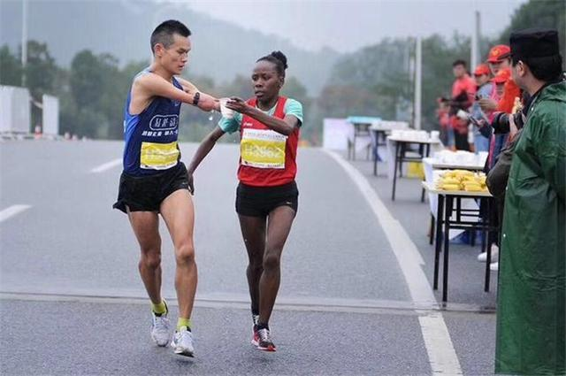
活动二: During reading
马拉松比赛感人的一幕！无论比赛还是做人，她都赢了！

比赛时，运动员是否会为了别人而放慢脚步？
2017年10月15日中国的马拉松比赛出现了一个感人的故事。一位来自埃塞俄比亚(Āisàiébǐyà “Ethiopia”) 的女运动员放慢了脚步，在补水处拿水喝，但是她不是为了自己，而是把水拿给了身旁来自中国的断手运动员。对运动员来说，这样是会影响输赢的，所以运动员很少会为了别人放慢速度。这一幕不但让现场的观众感动万分，也温暖了全世界的人。这也许就是我们所说的「运动精神」。最后，她胜利地赢得了马拉松第一名。无论比赛还是做人，她都赢了。
断手运动员叫任耀，8岁时因为电击，意外地受了重伤，失去了他的双手，他不但没有消沉，反而将人生梦想寄托在马拉松比赛，用这样特别的方式鼓励自己，得到好成绩。
原文来源Original source：http://www.sohu.com/a/198384466_755361

Post-reading 小考：阅读理解
1) 选择题 (单选)
- ____ 任耀是哪一国人？
a) 美国人 b) 英国人 c) 中国人 d) 泰国人
- ____ 女运动员是哪一国人？
a) 加拿大人 b) 古巴人 c) 墨西哥人 d) 埃塞俄比亚人
- ____ 马拉松指的是哪种运动？
a) 赛马 b) 赛车 c) 拔河 d) 跑步
- ____ 马拉松比赛中，谁放慢了速度？
a) 任耀 b) 男运动员 c) 女运动员 d) 现场观众

2) 完成表格 & 大意
- 完成表格Complete the graphic organizer.
- 口述大意Please summarize the article orally.
主角 | 国籍 | 比赛地点 | 喝水/拿水 | 感人的原因
 | 中国 |  |  | 1. _______________________  2. 运动没有国界
女运动员 |  |  | 拿水

3) 想一想
- 为什么说 “无论比赛还是做人，她都赢了”?
- 如果你是那位女运动员，你是否会为了断手运动员而放慢脚步?为什么？
活动三：三篇文章主旨
文章 | 文章主旨
文本一
《永远24》
文本二
《冬奥开幕式：韩朝手牵手》
文本三
《马拉松比赛感人的一幕》

- 这三篇文章的主旨有什么相同的地方？
- 谈谈你们个人对运动比赛的看法？运动比赛最重要的目的是什么？

活动四: 作业分享
1) Phase III Homework
- 跟同学分享你的 Phase III Homework
- 比较同学和自己的想法
 | 同学的想法 | 你的想法
相同的地方 | 1、  2、  3、
新观点/  新事物 | 1、  2、  3、

2) Phase IV Homework
- 跟同学分享你的 Phase IV Homework
- 比较同学和自己的想法
 | 同学的想法 | 你的想法
相同的地方 | 1、  2、  3、
新观点/  新事物 | 1、  2、  3、

活动五: 写作（运动比赛之我见）
Now that you have read three different articles regarding sport games/races and have discussed your viewpoints with your classmates. Integrate what you have learned and found out by posting an in-depth analysis report on your blog. Think critically and write strategically. Use 10-15 newly learned vocabulary as well as 3-5 sentence structures to present your view coherently with supporting and logical arguments.
Language Building Blocks
Core vocabulary | Supplementary vocabulary | Sentence structure
永远、赢、成功、球场、球迷、拥抱、脱、梦想、撞、牌、 受伤、实现 | 胜利、与众不同、四强、致谢、露出、印、之、意外、离世、悲痛、万分、消沉、负 | - 当……时，……  - 不但neg……,反而……  - 用/以…方式/方法/办法/手段＋vp.…

Organization
Part 1: Introduction – Initiate the topic discussion by summarizing the main text of the readings. Define your main topic/question, and explain why you are interested in the topic.
e.g. 2018世界杯 克罗地亚 vs 法国队 “永远24”
Part 2: Supporting Ideas – Incorporate authentic materials or class discussion notes into this section.
e.g.运动见真情；运动超越民族；运动没有国界
Part 3: Connections and Comparisons – Your analysis. Similarities and differences? Why?
e.g. 相同的地方 VS 新观点/新事物

Part 4: Close and Summary – What is discussed in this writing assignment? Summary of main arguments.

Writing Rubric
Grading Rubric | Exceeds Expectations  100% | Meets Expectations  75% | Does Not Meet Expectations  50% or below
Text Type | Write in paragraphs and connected sentences | Write in paragraphs sometimes, but mostly connected sentences. | Write in strings of sentences, some complex sentences
Organization & Structure | Organize writing in a logical manner with some cohesive devices. Writes with fluency. Includes anecdotes and detailed examples. | Organizes writing in a logical manner with few cohesive devices. Pauses a few times, disrupting the flow. | Focus mostly on task completion; paying little attention to organization and flow of writing.
Comprehensibility | It is easily understood by native speakers, even those unaccustomed to interacting with language learners. | There may be some confusion about the message but generally understood by those unaccustomed to working with language learners. | Generally understood by those used to interacting with language learners.
Vocabulary & Grammar | Consistently use an extensive vocabulary to complete the task, especially the ones we just learned. | Use an adequate vocabulary to complete the task, especially some of the ones we just learned. | Use vocabulary insufficient to complete the task. Did not consciously use the new ones we just learned.
Quantity | Complete message. Sufficient. | Needs to write more. | Incomplete. Insufficient.

